**Music Tracker User Guide**

COSC 457- Database Management Systems

Dr. Conover

Due: December 11, 2015

By: Emily Evans, Miguel Fernandez, Brenton Smelser, Shannon Smith

Table of Contents

# Home Page………………………………………………………………………………………2

Login……………………………………………………………………………………………...2

Register…………………………………………………………………………………………..3

Logged In Home Screen………………………………………………………………………..3

View Artists……………………………………………………………………………………....4

View Albums……………………………………………………………………………………..5

View Performances...........................................................................................................6

View Venues.....................................................................................................................7

Edit Profile........................................................................................................................8

Add Comment...................................................................................................................8

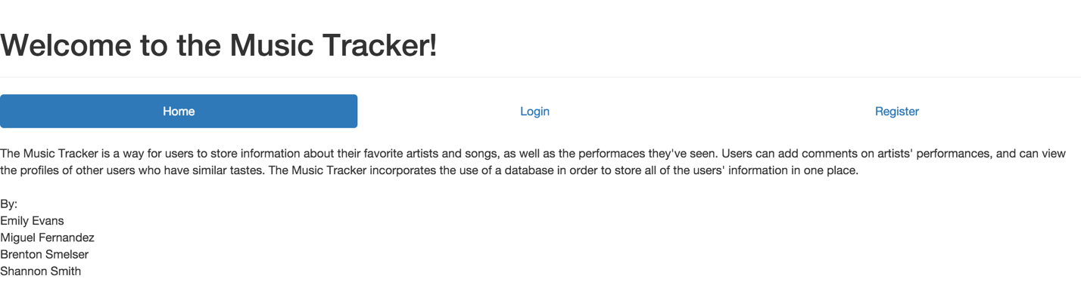**Home Page**

Once a user goes to the home page of Music Tracker, they can login if they already have an account or register for an account if they are a new user.

**Login**

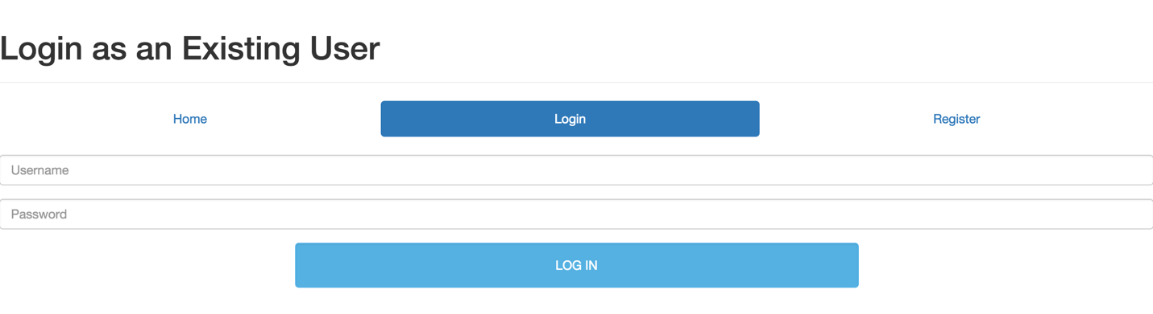

If you are an existing user, you may enter your username and password in order to log in to the Music Tracker.

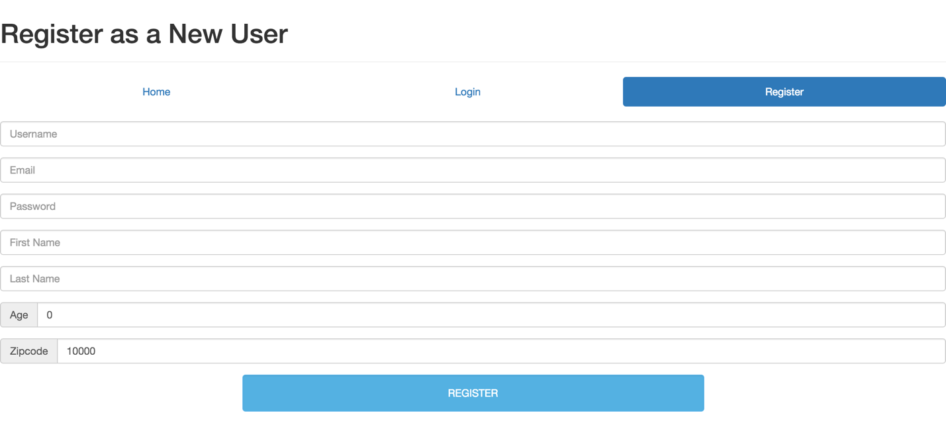**Register**

In order to register as a new user in the Music Tracker, you must create a username and password. You must also supply your email address as well as your first name and last name. Your age and zip code must also be provided.

**Logged In Home Screen**

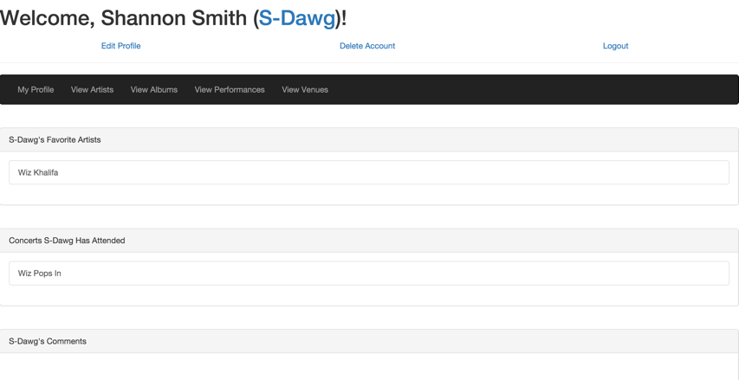

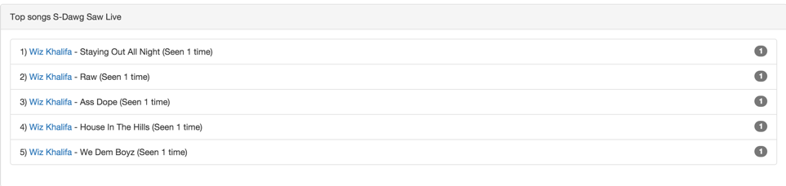

The home screen for the logged in user shows the user’s favorite artists, what concerts the user has attended, any comments the user has made, and the top songs that the user has seen live.

**View Artists**

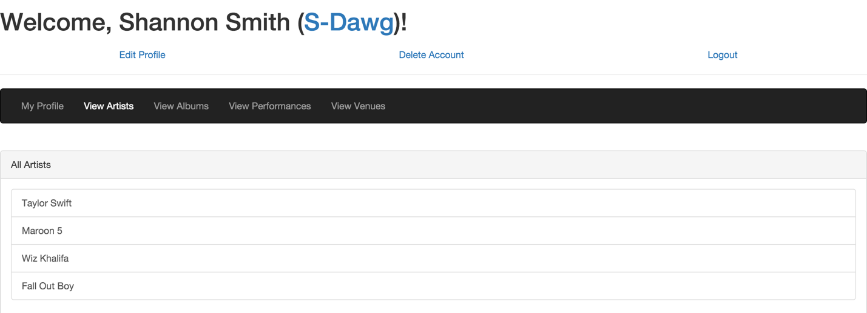

When clicking on “View Artists” near the top of the page, a user can see all of the artists in the database. If you click on a particular artist, you are able to see their members, albums, performances, who else in the database has this artist as their favorite, and comments that other users have made about the artist. You can also add this artist as your favorite if you so wish.

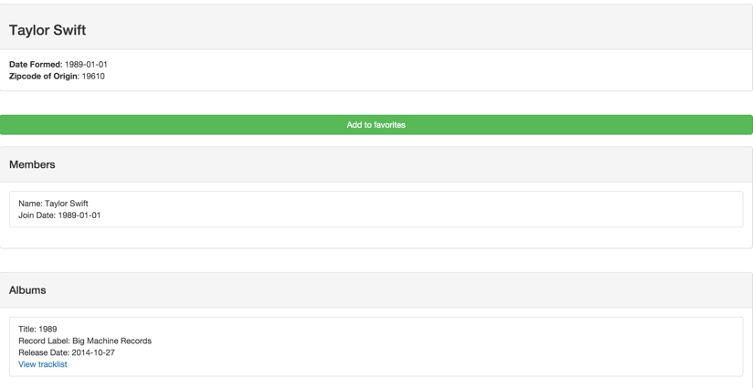

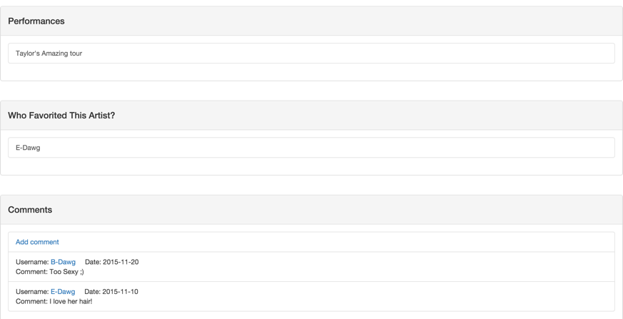

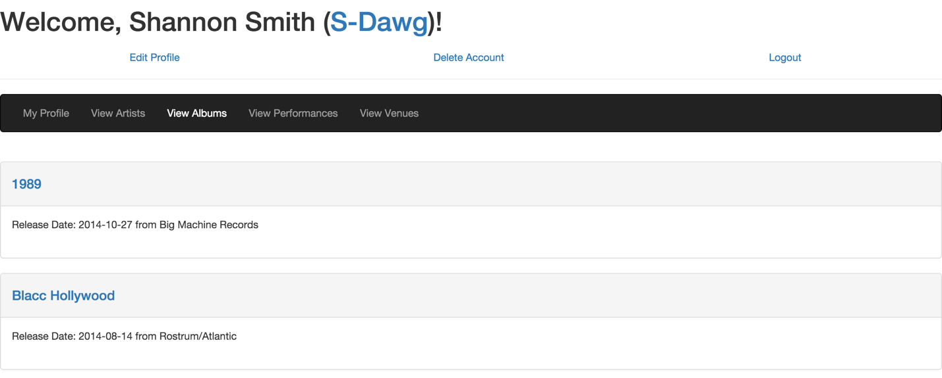**View Albums**

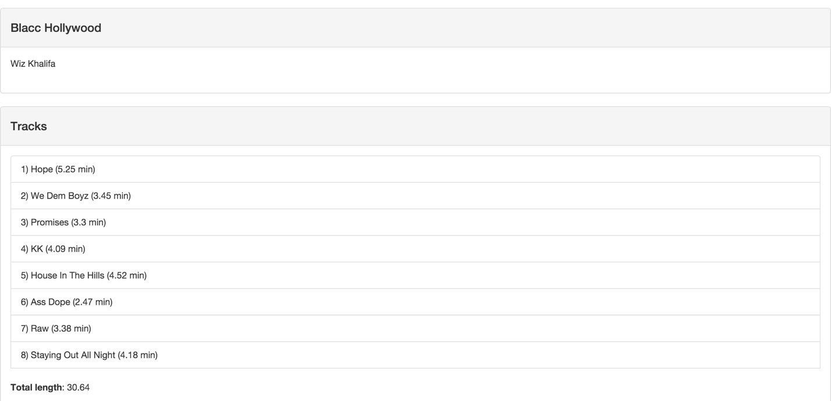When a user clicks on “View Albums”, they are directed to a page with the albums that the user has made a favorite.

Once the user clicks on a specific album, they are taken to another webpage that has the tracks on the album as well as the times of each track and the total time it would take to play the album.

**View Performances**

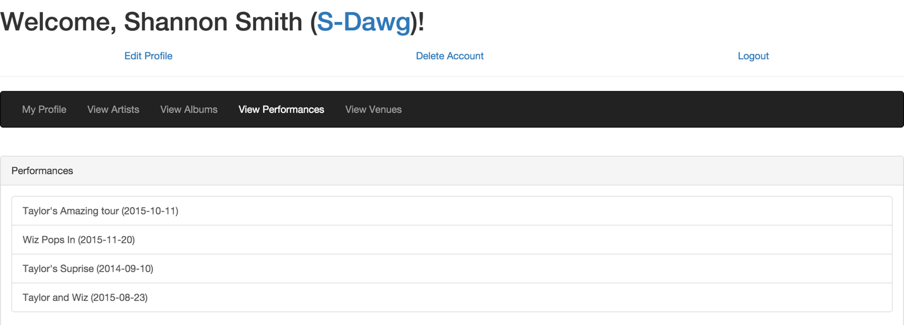

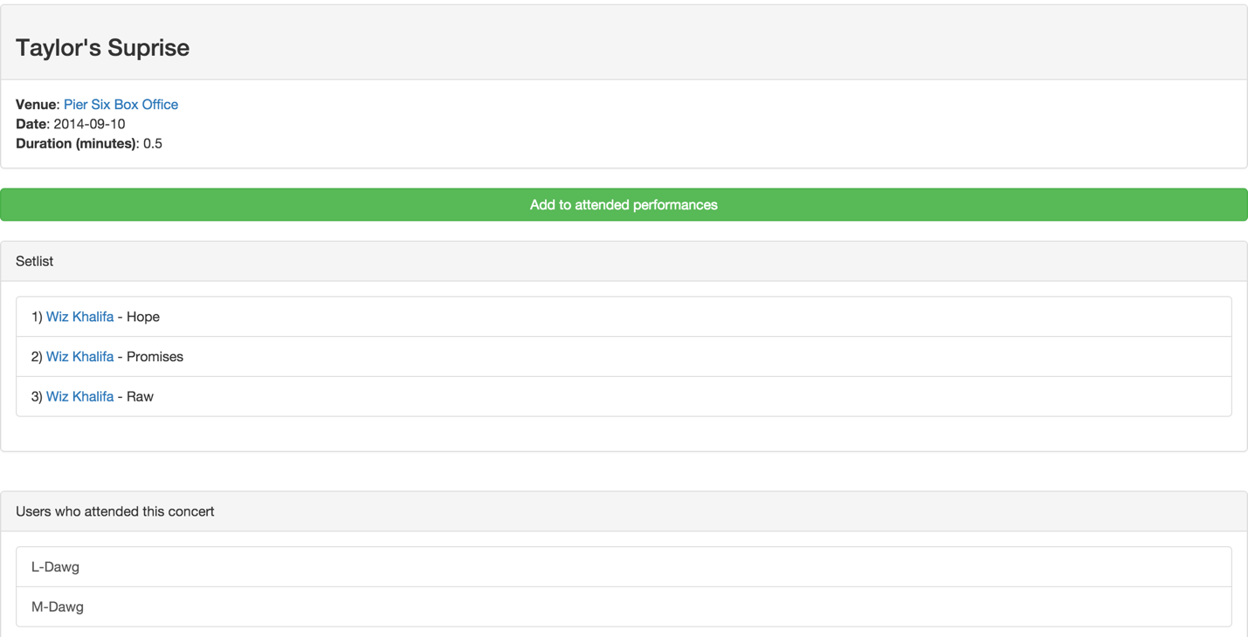The user is able to see the performances of their favorite artists when they click on “View Performances”.

Once the user clicks on a specific performance, they are taken to a page that shows what venue the concert was performed at as well as the set list for that particular performance, and other users in the database that also attended that performance.

**View Venues**

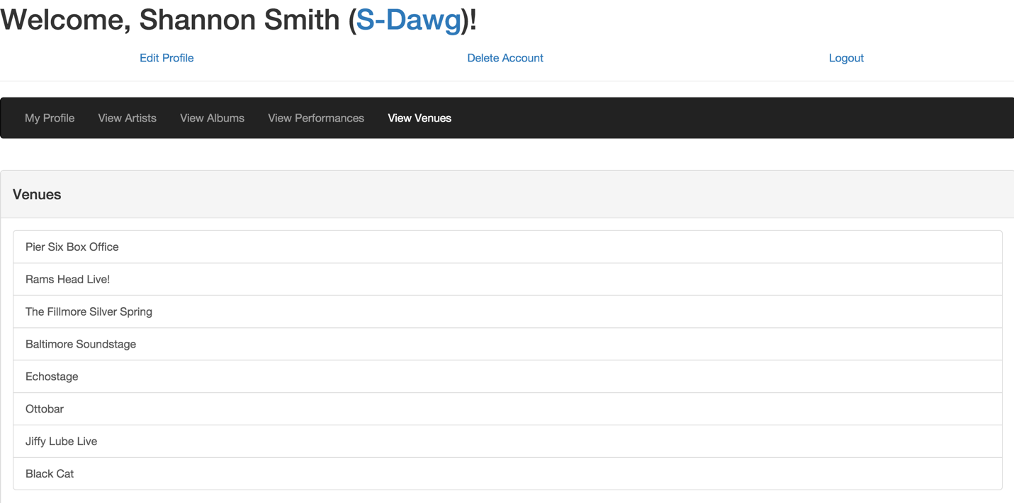

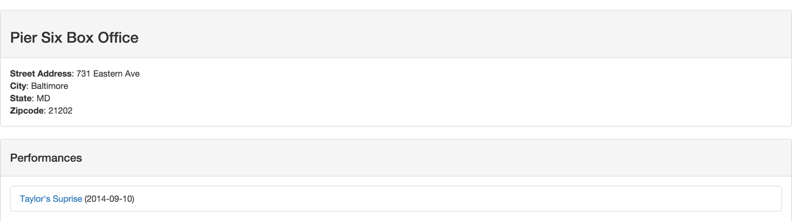When the user clicks on “View Venues”, they are taken to the screen above which lists all of the venues where performances can happen. After clicking on a venue, the address, city, state, and zip code are displayed as well as what performances have occurred at that particular venue.

**Edit Profile**

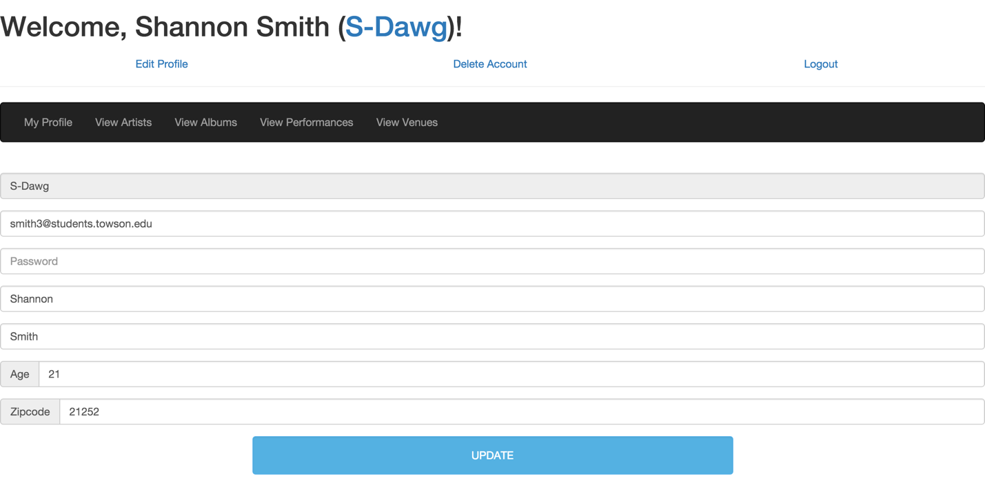

If a user needs to edit their profile after they have created it, they are able to do so. Simply clicking on the “Edit Profile” link near the top left corner will take them to this page where they are able to change any aspect of their profile. Clicking “update” will save any new changes to the profile.

**Add Comment**

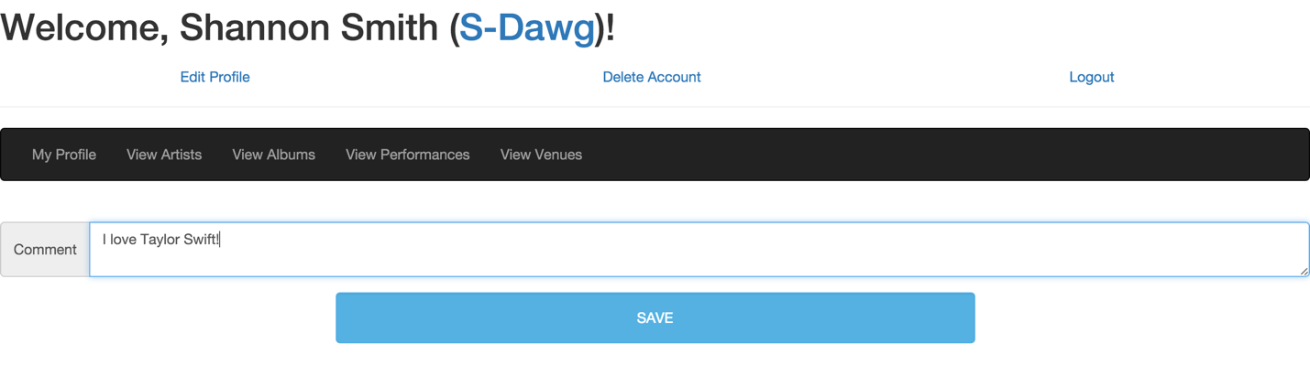

A user is able to add a comment by clicking on “View Artists”, then clicking on whatever artist they would like to comment on. They are taken to a page where they can enter their comment and hit “save” which will update the page and load their comment.